Memo 1/4/2021

In response to the comment from Jing’s email. “Furthermore, maybe we should calibrate both Amax and phi in each model to make similar average levels of BMAL (AT), and PER (P0+...+P) proteins”.

In summary, the formula for AT is rewritten as

dAt/dt = delta * (FCATR*AMAX/(1+V) - At) --- NNF models

dAt/dt = delta * (FCATR*AMAX*R/(1+R) - At) --- PNF models

where FCATR is the fold change in *BMAL* transcription, AMAX is the parameter for the maximum At, whose values are shown in the table below for different models such that the average At level is consistent with At value in SNF model, which is 0.1. Other parameter values are the same as the Supplemental Table S4.

|  |  |  |  |  |  |  |  |  |
| --- | --- | --- | --- | --- | --- | --- | --- | --- |
| **Param** | **NNF**  **(0L8)** | **NNF**  **(0M8)** | **NNF**  **(1M8)** | **NNF**  **(2M8)** | **PNF**  **(0L8)** | **PNF**  **(0M8)** | **PNF**  **(1M8)** | **PNF**  **(2M8)** |
| *A*MAX | 0.17 | 0.3 | 0.3 | 0.4 | 0.24 | 0.15 | 0.15 | 0.135 |
| *K*d | 10−3 | 0.1 | 0.1 | 0.1 | 10−3 | 0.1 | 0.1 | 0.1 |
| *R*MAX |  |  |  |  | 5 | 5 | 5 | 5 |
| *V*MAX | 5 | 5 | 5 | 5 |  |  |  |  |

Detailed results are shown on the following pages.

1. 0L8 models

#SNF

param Kd= 0.001, At=0.1

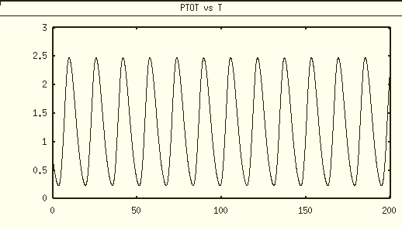

# NNF model

dAt/dt = delta * (FCATR*AMAX/(1+V) - At)

param Kd=0.001, delta=0.2, VMAX=5, AMAX=0.17

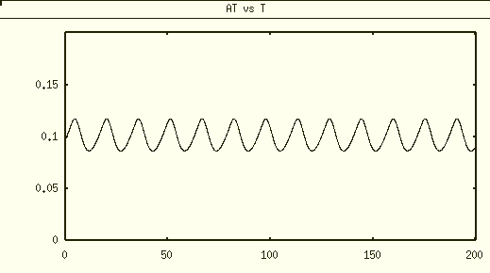

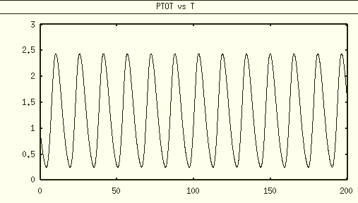

# PNF model

dAt/dt = delta * (FCATR*AMAX*R/(1+R) - At)

param Kd=0.001, delta=0.2, RMAX=5, AMAX=0.24

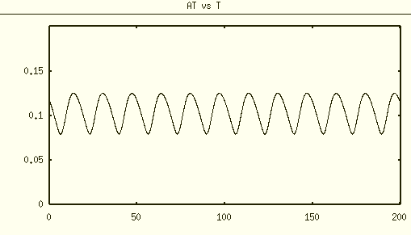

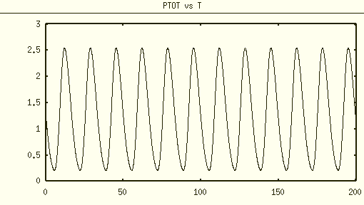

1. 0M8 models

#SNF

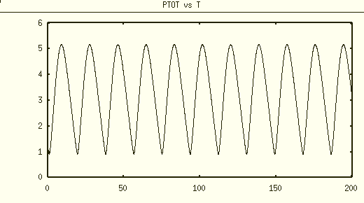

#NNF

dAt/dt = delta * (FCATR*AMAX/(1+V) - At)

param Kd=0.1, delta=0.2, VMAX=5, AMAX=0.3, FCATR=1

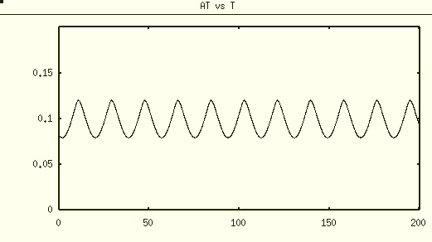

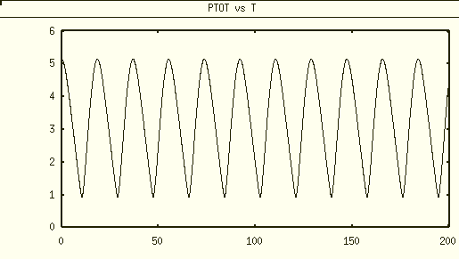

#PNF

dAt/dt = delta * (FCATR*AMAX*R/(1+R) - At)

param delta=0.2, RMAX=5, AMAX=0.15, FCATR=1

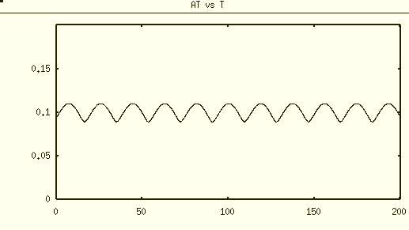

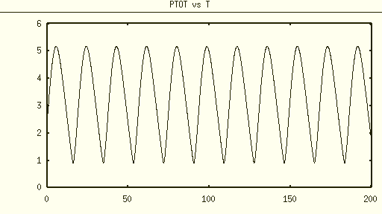

1. 1M8, AT=0.1 and phi=1

# SNF

Add an auxiliary variable Ptot = P0+P1+P2+P3+P4+P5+P

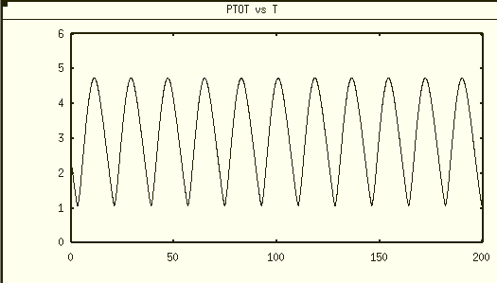

max Ptot ≈ 4.74, min Ptot ≈ 1.09, the average level of Ptot ≈2.92

# NNF model

dAt/dt = delta * (FCATR*AMAX/(1+V) - At)

param Kd=0.1, delta=0.2, VMAX=5, AMAX = 0.3

param FCATR=1

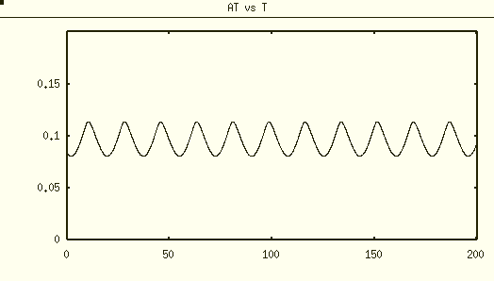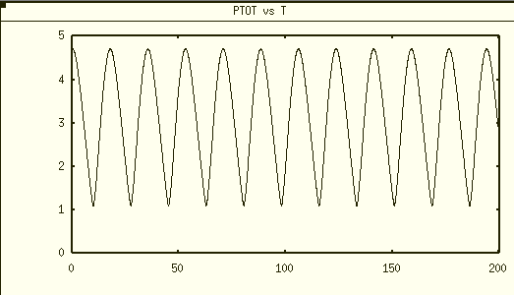

Ptot level is similar to SNF 1M8, with max≈4.71 and min≈1.11

# NNF AMAX=0.2

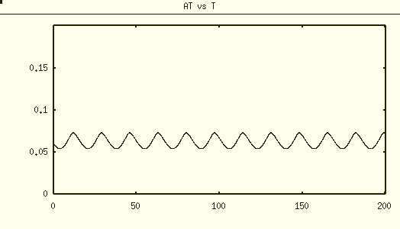

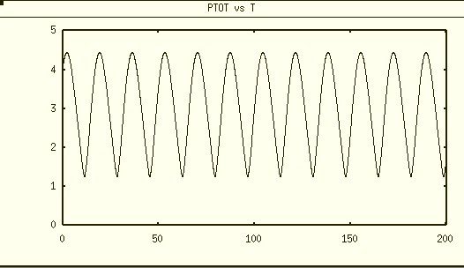

max≈4.44 and min≈1.25

PNF 1M8 calibration

# PNF model

dAt/dt = delta * (FCATR*AMAX*R/(1+R) - At)

param Kd=0.1, delta=0.2, RMAX=5, AMAX=0.15

param FCATR=1

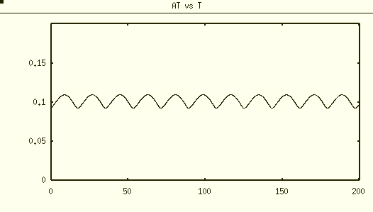

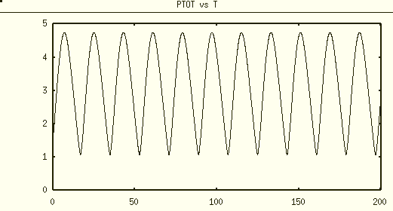

max≈ 4.74 min≈1.11

#PNF AMAX=0.2

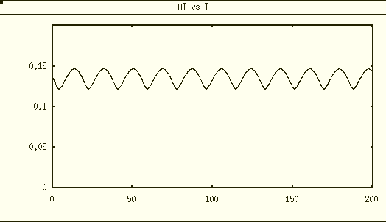

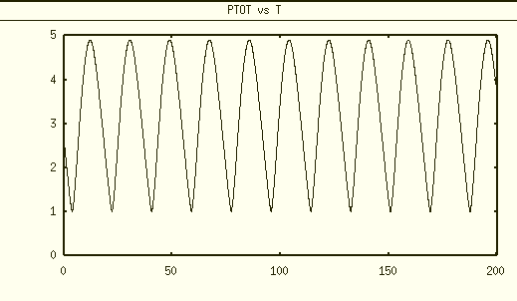

max≈ 4.90 min≈1.02

PNNF 1M8 calibration

# PNNF model

dAt/dt = delta * (FCATR*AMAX*(epsilon+R)/(1+R+V) - At)

param Kd=0.1, delta=0.2, RMAX=5, VMAX=5, epsilon=0.01,

param FCATR=1, AMAX=0.25

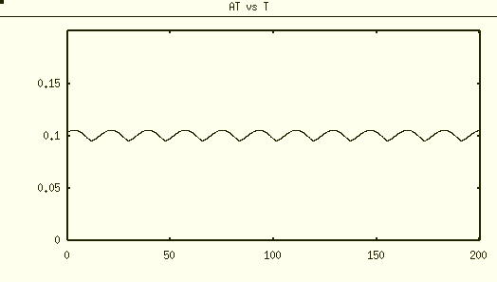

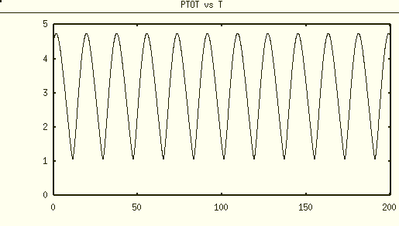

max≈ 4.74 min≈1.08

# PNNF AMAX=0.3

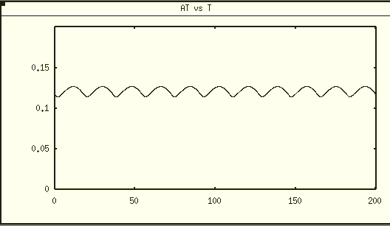

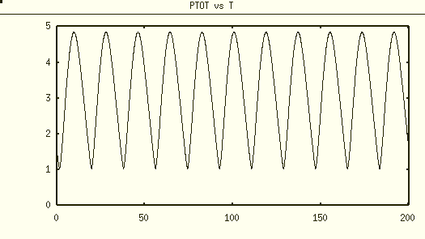

max≈ 4.85 min≈1.04

1. 2M8 models

#SNF

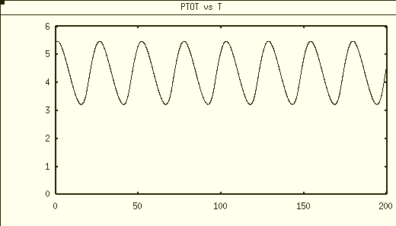

max≈ 5.48 min≈3.23

#NNF 2M8

dAt/dt = delta * (FCATR*AMAX/(1+V) - At)

param delta=0.2, VMAX=5, AMAX=0.4, FCATR=1

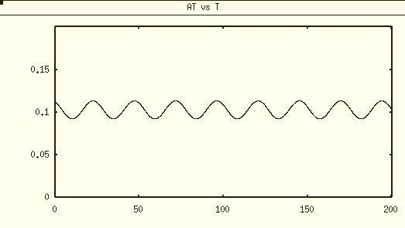  
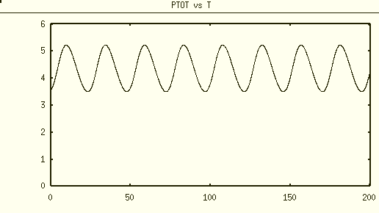

max≈ 5.23 min≈3.50

#PNF 2M8

dAt/dt = delta * (FCATR*AMAX*R/(1+R) - At)

param Kd=0.1, delta=0.2, RMAX=5, AMAX=0.135

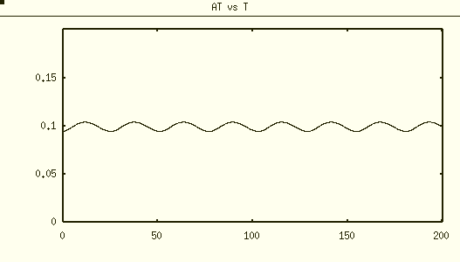

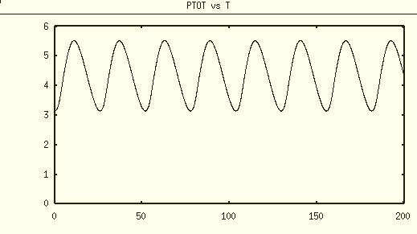

max≈ 5.52 min≈3.15

#PNNF 2M8

dAt/dt = delta * (FCATR*AMAX*(epsilon+R)/(1+R+V) - At)

param delta=0.2, RMAX=5, VMAX=5, epsilon=0.01, AMAX=0.24

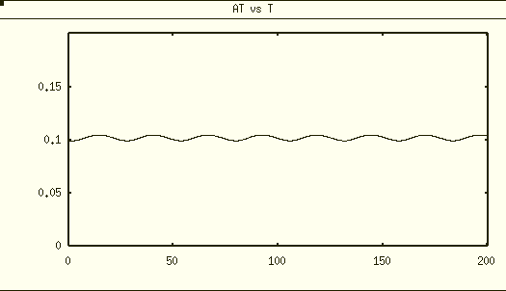

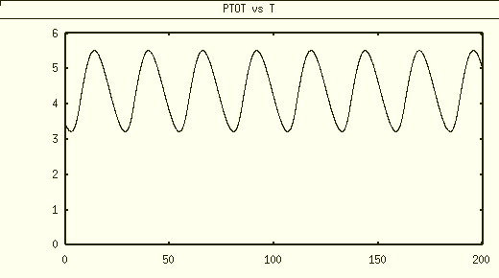

max≈ 5.52 min≈3.15